# BREAKFAST

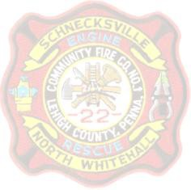

# **AT THE**

# SCHNECKSVILLE

# **FIREHOUSE**

Join us for our All-You-Care-To-Eat Breakfast Buffet

Serving from 8 am – 12 noon

SUNDAY January 26, 2025

EGGS [Any way you like ‘em]

Ham ~ Sausage ~ Cream Chip Beef (SOS)

Home Fries ~ Pancakes ~ Toast Coffee ~ Tea ~ Orange Juice ~ Hot Chocolate

COST

Adults - $13.00 Child (5 to 12) - $7.00

Child (under 5) -FREE

ALL PROCEEDS BENEFIT YOUR VOLUNTEER FIREFIGHTERS